|  |
| --- |
| Cambridge IGCSE Design Technology |
| Assessed Task Guidance Notes Examination 2016 |
| Systems & Control Option |

**Name : _____________________________________________**

**Contents Page**

**Page 3: Schedule for Year 11 & Assessment Overview**

**Page 4: Assessed Task Deadlines**

**Page 5: Assessed Task Design Briefs**

**Page 6: Design Folder Contents Guidelines**

**Page 8: Assessment Criteria for the Assessed Task**

**Page 10: Sample Task Analysis**

**Page 11: Notes**

***Confucius says.....***

***“Your teacher knows more about this task than you do! Follow his path and be successful..... Follow your own path and you will be lost.”***

***Confucius also says.....***

***“Do these three things and you will be successful.***

* ***Listen to the advice given***
* ***Follow the advice given***
* ***Don’t waste your time and work effectively”***

**Cambridge IGCSE Examination Summer 2016**

**Assessed Task Guidance Notes**

**Schedule for Year 11 & Assessment Overview**

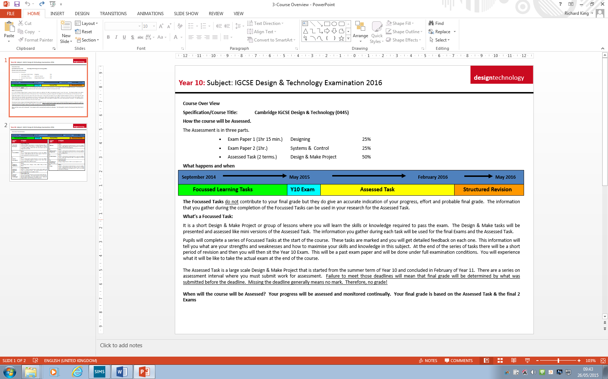

**Cambridge IGCSE Examination Summer 2016**

**Assessed Task Guidance Notes**

**DEADLINES**

**The deadlines are NOT negotiable. It is your responsibility to meet them and to have the required work completed ON or BEFORE that time.**

* **Completed Artefact** (Practical Work) on or beforethe start of the first Technology lesson **week beginning Monday 1st February 2016.**
* **Completed Design Folder** submitted for final assessment at the start of the first Technology lesson **week beginning Monday 7th March 2016.**

**ALSO**

In order to help you manage your time effectively there are a series of interim deadlines by which you should have completed the various sections of the Design Folder.

**Section One** start of the 1st lesson **after the summer holidays**

**Section Two** end of the 2nd lesson **week beginning 7th September 2015**

**Section Three** end of the 2nd lesson **week beginning 14th September 2015**

**Section Four** end of the 2nd lesson **week beginning 28th September 2015 Section Five** end of the 2nd lesson **week beginning Monday 7th February 2016.**

**Section Six** start of the 1st lesson **week beginning Monday 7th March 2016.**

**WARNING**

Many candidates make these mistakes!

* They think it is the teacher’s responsibility to make sure that the work is done in time. **It is not.**
* They think the practical work is more important than the Design Folder! **It is not.**
* They underestimate the amount of work required for this project and fail to produce enough work to get the grade that they expect.
* They think that they will be able to have an extension to the deadlines. **They will not.**
* They think that they will be able to produce the work required the night before it is due to be handed in. **They don’t.**
* They think that they will be given additional time to finish the practical work. **They will not.**
* They think that they will not encounter any problems and that everything will work out fine! **It will not.**
* They think that if they lose their work they will be given an estimated grade! **They will not**
* They think that if they are absent from school they will be given extra time to compensate. **They will not.**

**Cambridge IGCSE Examination Summer 2015**

**Assessed Task Guidance Notes**

**IGCSE Assessed Task Design Briefs**

The Assessed Task is an extended Design & Make Project which is worth 50% of your final IGCSE grade. It will take several months to complete. It will start in September 2013 and must be completed by the end of February 2014. The examination regulations make it quite clear that all of the work must be your own.

**The Design Folder is worth: 70% of the marks.**

**The Artefact (practical work) is worth: 30% of the marks.**

In order to assist you in managing such an extensive piece of work you will be provided with guidelines and a series of interim-deadlines for completion of the various stages of the project. Failure to hand in work on time will result in that work not being assessed.

**You must select one of the follow problems to solve.**

**Design Brief One – Microprocessor controlled storage system**

The storage of everyday items is a common problem both at home or at work. Investigate a particular storage problem of your choice for small everyday items. Then Design and Make a suitable solution which uses a motorised control system to solve that storage issues that you have identified.

**Design Brief Two – Microprocessor controlled point of sale display system**

Every shop or business needs to advertise its goods for sale in the most effective way. Shop keepers are adopting more and more innovative promotional displays in order to attract customer interest. Investigate a particular point of sale problem of your choice and then Design and Make a suitable microprocessor controlled solution to solve the issues that you have identified.

**Design Brief Three – Microprocessor controlled food vending system for a small animal**

Many people keep small caged animals as pets; feeding the animal regularly whilst the owner is away for a few days is a common problem. Investigate a particular pet feeding problem of your choice and then Design and Make a suitable solution which uses a motorised control system to dispense measured amounts of food at the required intervals.

*****

**Cambridge IGCSE Examination Summer 2015**

**Assessed Task Guidance Notes**

**Design Folder Contents Outline**

Page 1 Front Cover ZERO MARKS

Pages 2 & 3 Introduction/Design Brief/Task Analysis 5 marks

Pages 4 - 6 Research/Analysis of Research/ Product Specification 10 marks

Pages 7 – 10 Generation of Initial Ideas 20 Marks

Pages 11 – 13 Development of a solution 15 Marks

Pages 14 – 18 Planning for Production (links with the Making – 30 marks) 10 Marks

Pages 19 – 21 Product Testing/Evaluation/Further Developments 10 Marks

The Design Folder will be produced using Microsoft Publisher in landscape format and able to be printed out as an A3 colour document using the Technology Department Printer.

**Checklist of Contents** *(Put a line through each of these items when completed)*

**Introduction/Brief/Task Analysis (Slides 2 & 3)**

* A statement of the **Design Problem**. **(Slide 2)**
* Describe in detail the reasons why you have chosen this particular problem to design a solution for. Illustrate your justification with real life examples and describe the sorts of problems that people have experienced.
* Provide examples of a range of similar products that have been designed to address the same or similar problems.
* Explain how your solution will be different or better than the examples you have shown. In particular describe the needs of your intended target user/s.
* Give a **DESIGN BRIEF** for the problem you have chosen. This is a description of what you will make and what it will do.
* Complete a detailed **TASK ANALYSIS** **(Slide 3)** of what skills you will need have and what to information you will need to know in order to complete this design and make task. (Spider Diagram)

**Research/Analysis of Research/ Product Specification Slides 4 – 6**

* A Mood Board (If appropriate)
* The research information about all of the topics identified in the task analysis – only include relevant information.
* A summary of the research.
* A detailed (bullet point) product specification list.

**Generation of Initial Ideas Slides 7 – 10**

* A set of 3 or 4 alternative annotated design ideas. (Alternative means radically or totally different.) These should be hand-drawn sketches which have been scanned and inserted into your document. Text boxes can be used to add annotations if desired.
* The sketches should be a mixture of 2D and 3D images and clearly labelled.
* State sizes, materials how it works.
* The designs must be evaluated. (This means produce a list of good and bad points about each design.)

**Development of a solution Slides 11 – 13**

* A detailed and fully annotated 3D sketch of your chosen design. You can use include additional 2D annotated sketches if you wish.
* If possible, include versions of your designs or parts of your design that you have produced using SolidWorks/2D Design or any other CAD package that you may have used.
* Include any evidence (photographs) of models/prototypes of the product that you may have used.
* Justify the selections of materials, shape and size.

**Planning for Production (links with the Making – 30 marks) Slides 14 – 18**

* A plan of action for making your artefact. (This is an outline of the sequence of building activities that you will followed.)
* A parts list.
* A series of detailed illustrated step-by-step instructions that show how to build the project. Photographic evidence is essential.

**Product Testing/Evaluation/Further Developments Slides 19 – 21**

* This section is divided into three sub-sections
* **Modifications -** This is where you describe any problems that you encountered during the making process and how you fixed them. Photographic evidence is essential for this process. Present each problem in a bullet point list.
* **Performance -** This is where you compare the actual finished product to the specification list that you formulated on slide 6. Create a two column table with the specification criteria on the left and then on the right-hand side state how and why each criterion has been achieved or not.
* **Future Improvements -** This is where you explain how you could improve your product if you were to make more of them (mass production). Include information about better materials selection and any environmental implications. Include information about Health and Safety in the manufacturing process and for the end user. Explain how future developments in manufacturing or materials technologies will influence the design of yours and similar products.

**********

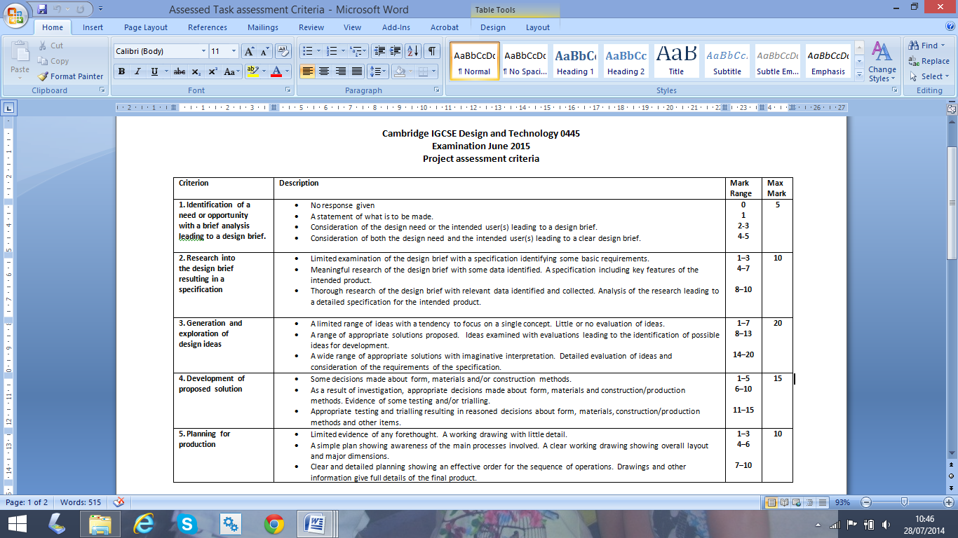

**Assessment Criteria**

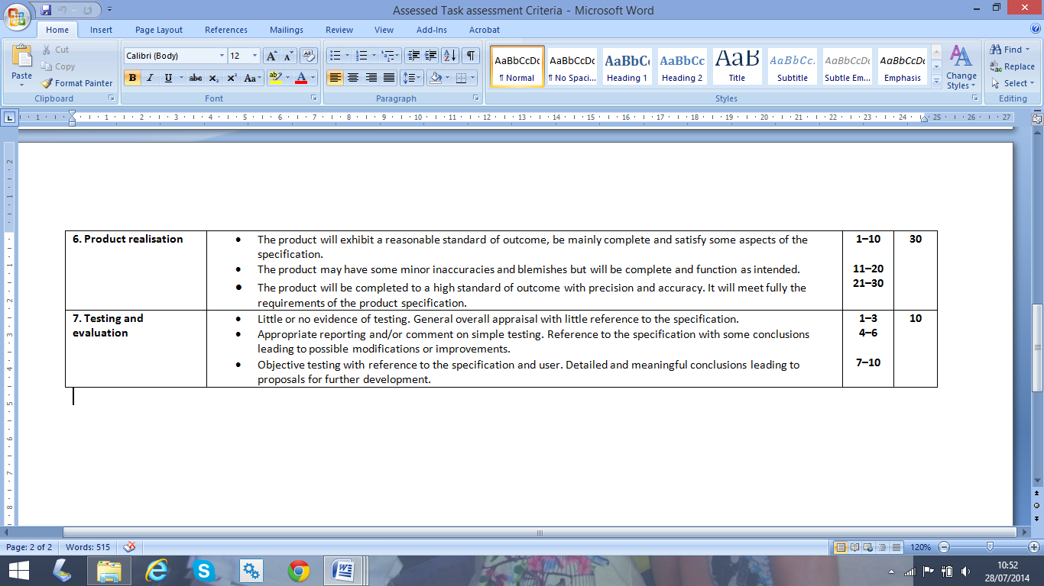

**Cambridge IGCSE Examination Summer 2016**

**Assessed Task Guidance Notes**

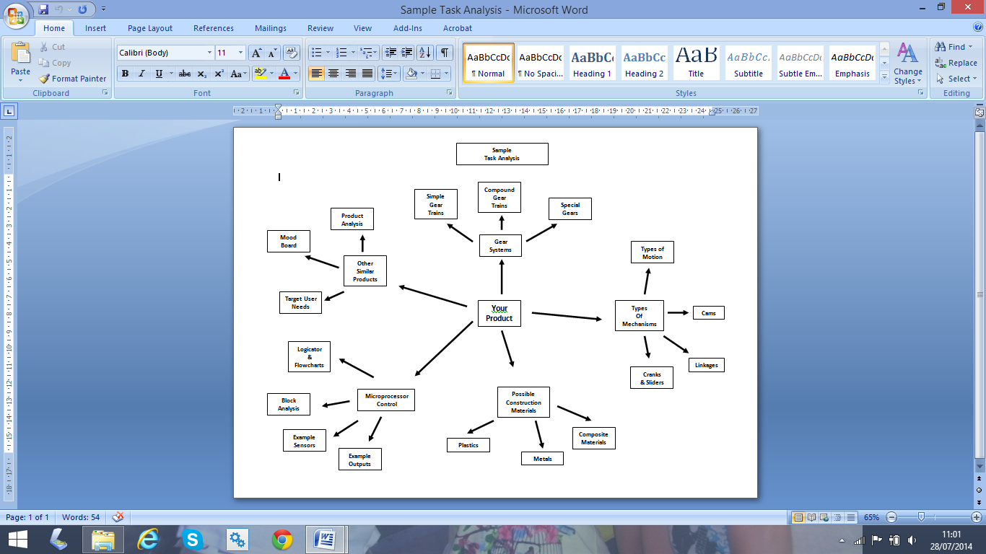**Sample Task Analysis**

Notes : ________________________________________________________________________________________________________________________________________________________________________________________________________________________________________________________________________________________________________________________________________________________________________________________________________________________________________________________________________________________________________________________________________________________________________________________________________________________________________________________________________________________________________________________________________________________________________________________________________________________________________________________________________________________________________________________________________________________________________________________________________________________________________________________________________________________________________________________________________________________________________________________________________________________________________________________________________________________________________________________________________________________________________________________________________________________________________________________________________________________________________________________________________________________________________________________________________________________________________________________________________________________________________________________________________________________________________________________________________________________________________________________________________________________________________________________________________________________________________________________________________________________________________________________________________________________________________________________________________________________________________________________________________________________________________________________________________________________________________________________________________________________________________________________________________________________________________________________________

Notes : ________________________________________________________________________________________________________________________________________________________________________________________________________________________________________________________________________________________________________________________________________________________________________________________________________________________________________________________________________________________________________________________________________________________________________________________________________________________________________________________________________________________________________________________________________________________________________________________________________________________________________________________________________________________________________________________________________________________________________________________________________________________________________________________________________________________________________________________________________________________________________________________________________________________________________________________________________________________________________________________________________________________________________________________________________________________________________________________________________________________________________________________________________________________________________________________________________________________________________________________________________________________________________________________________________________________________________________________________________________________________________________________________________________________________________________________________________________________________________________________________________________________________________________________________________________________________________________________________________________________________________________________________________________________________________________________________________________________________________________________________________________________________________________________________________________________________________________________________

Notes : ________________________________________________________________________________________________________________________________________________________________________________________________________________________________________________________________________________________________________________________________________________________________________________________________________________________________________________________________________________________________________________________________________________________________________________________________________________________________________________________________________________________________________________________________________________________________________________________________________________________________________________________________________________________________________________________________________________________________________________________________________________________________________________________________________________________________________________________________________________________________________________________________________________________________________________________________________________________________________________________________________________________________________________________________________________________________________________________________________________________________________________________________________________________________________________________________________________________________________________________________________________________________________________________________________________________________________________________________________________________________________________________________________________________________________________________________________________________________________________________________________________________________________________________________________________________________________________________________________________________________________________________________________________________________________________________________________________________________________________________________________________________________________________________________________________________________________________________________